2024

Evans Intensive English Centre

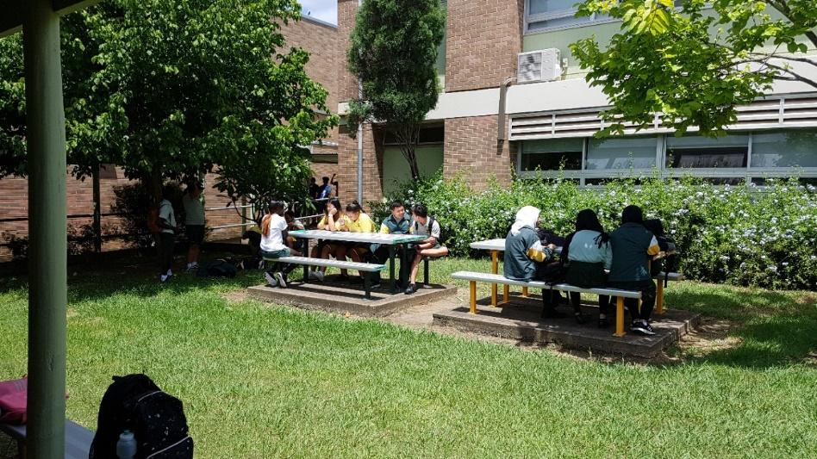

Student Handbook

Evans Intensive English Centre
Welcome to
Evans Intensive English Centre

Evans Intensive English Centre is hosted by Evans High School. It is part of the NSW secondary school system. It offers initial placement for newly arrived students, refugees, and fee-paying internationals who require support in developing English proficiency and are of secondary school age living in western and north-western Sydney.

Students receive an intensive English program while studying most of the high school subjects including English, Mathematics, Science, History, Geography and PDHPE.

The Centre also provides programs designed to assist the students to adjust to school and life in Australia.

After completing the Intensive English Program, which ranges from 3-15 months, students are then enrolled in their local or preferred high school which offers continuing EAL/D support.

This information booklet has been developed for parents and students. It contains information about our school, requirements, expectations, and answers some frequently asked questions.
Welcome to our school.

Evans IEC Directory

166 Walters Road Blacktown NSW 2148

9622 1289
0405 461 564
evans-i.school@det.nsw.edu.au

Staff
Principal Mrs Nerina Pretlove
Deputy Principal Mrs Mee Lin Liau
Head Teacher Miss Mary Kavanagh
Relieving School Administrative Manager Ms Trisha Briggs
School Administration Officers Mrs Kylie Lenz
Mrs Mylinda Leung
School Counsellors Miss Aarezo Sherzay
Ms Meg Huckstep
Miss Olivia Parrott

Term Dates For 2024
Term | Start | Finish
1 | Thursday 1 February | Friday 12 April
Autumn Holidays Monday 15 April – Friday 26 April
2 | Tuesday 30 April | Friday 5 July
Winter Holidays Monday 8 July – Friday 19 July
3 | Tuesday 23 July | Friday 27 September
Spring Holidays Monday 30 September – Friday 11 October
4 | Monday 14 October | Wednesday 18 December
Summer Holidays Monday 23 December – Friday 31 January
Public Holidays
School is not open on these days
Good Friday | Term 1 | Friday 29 March
Easter Monday |  | Monday 1 April
King’s Birthday | Term 2 | Monday 10 June

Behaviour Expectations
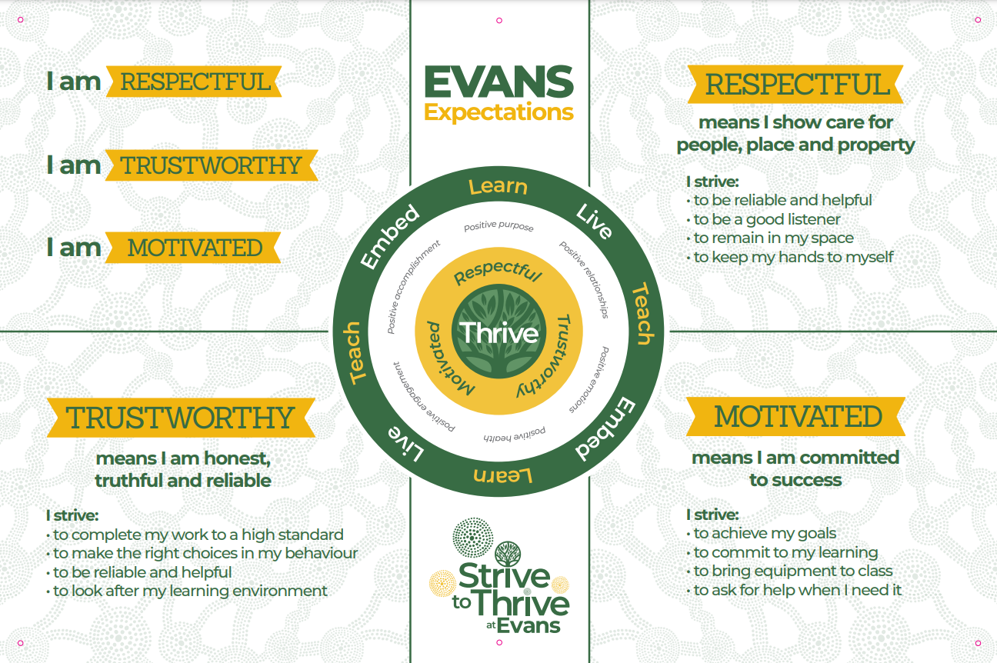

 | Monday | Tuesday | Wednesday | Thursday | Friday
Roll Call | 8.35 - 8.45 | 8.35 - 8.45 | 8.35 - 8.45 | 8.35 - 8.45 | 8.35 - 8.45
Period 1 | 8.45 - 9.45 | 8.45 - 9.35 | 8.45 - 9.45 | 8.45 - 9.45 | 8.45 - 9.45
Period 2 | 9.45 - 10.45 | 9.35 - 10.25 | 9.45 - 10.45 | 9.45 - 10.45 | 9.45 - 10.45
Assembly | - | 10.25 - 10.45  Week A: Whole School  Week B: IEC | - | - | -
Recess | 10.45 - 11.15 | 10.45 - 11.15 | 10.45 - 11.05 | 10.45 - 11.15 | 10.45 - 11.15
Period 3 | 11.15 - 12.15 | 11.15 - 12.15 | 11.05 - 12.05 | 11.15 - 12.15 | 11.15 - 12.15
Period 4 | 12.15 - 1.15 | 12.15 - 1.15 | 12.05 - 1.05 | 12.15 - 1.15 | 12.15 - 1.15
Lunch | 1.15 - 1.45 | 1.15 - 1.45 | School ends | 1.15 - 1.45 | 1.15 - 1.45
Period 5 | 1.45 - 2.45 | 1.45 - 2.45 | - | 1.45 - 2.45 | 1.45 - 2.45

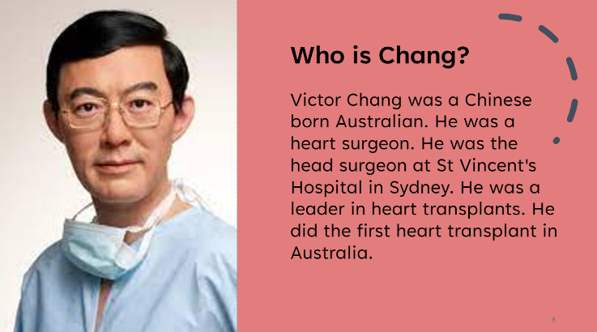
House Groups

- At Evans IEC, we have four houses. Change, Freeman, Irwin, and Kerr. When you enrol, you will be placed in a house depending on your language. Each house is a specific colour. You can read about our houses on the left.

- Your house is also your roll call group. You will attend roll call every morning where the teacher will ensure that you are dressed in the correct uniform, your mobile phone is locked away and you are on time.

- When we have the athletics, swimming, or cross-country carnival, you are encouraged to wear the colour of your team and participate for your house. Participating in races, accrues points for your house. Team spirit is important at Evans.

- Throughout the year, you accrue points for respectful, trustworthy, or motivated behaviour. At the end of the year, the winning house is rewarded.

Communication & Support

Interpreters
The school can provide interpreters for parents/carers needing access to such a service. Please contact the principal if an interpreter is required for any meeting. For telephone interpreting, phone TIS on 131 450.

School Counsellor
All students can access the school counsellors. They provide assistance to students experiencing emotional, psychological, social and learning problems. In supporting students, school counsellors will also provide advice to parents and teachers as appropriate. If parents wish to speak to the counsellor, an appointment can be made by telephoning the school.

Change of Address
The IEC needs to know each student’s address and telephone number. If these change, please inform the office staff who will give you a Change of Address form to fill out, get signed by a parent/guardian and then return to the office. Your address will affect the high school you will enrol in once you finish in the IEC.

Equipment List
Please see below the requirements for students in 2023. You will receive your book pack when you purchase your uniform.
Important: One book for each subject is required and each book is to have the student’s full name written on the cover. Individual teachers will inform students of subject specific requirements.

Excursions
Excursions are part of the curriculum, and it is important that every student attends. Excursions are not regarded as holidays. The IEC subsidies excursions to help parents who are new to Australia. A note will be sent home for all excursions. This note should be signed by the parent/carer and returned to the school. A student without a signed note cannot go on the excursion. Excursions are usually in school hours (between 8:35 am and 2:45 pm). Only students at the IEC may attend.
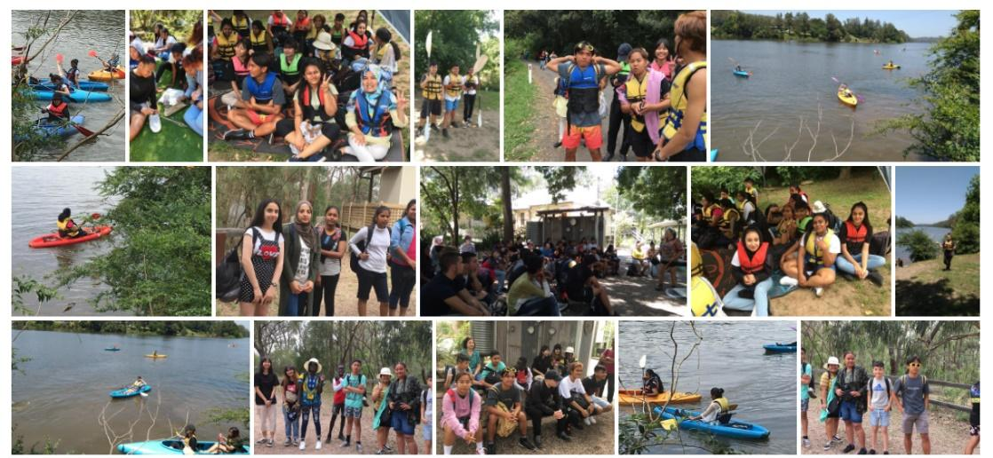

Attendance
It is compulsory for children to go to school in Australia until the age of 17. School operates from Monday to Friday. School hours are from 8:35 am until 2:45 pm. Students need to be punctual.
Absences | Parents must provide an explanation for absences. This can be via telephone call, written note, text message or email to the school within 7 days from the first day of any period of absence. If your child is absent, a note must be sent with the child when he/she returns to school. It should have the date, the child’s name, and roll call and the reason. The parent/carer must sign the note (not the student). If the child is to be absent for more than three days, please provide a medical certificate upon return. If your child is absent from school because they are sick, a doctor’s certificate may be required.
Early Departure | Students are to bring a note from a parent/carer and report to the Front Office before school to receive an early leaver’s pass. Parents/carers should note that permission to leave school early will only be granted for specialist medical, dental, or legal appointments or in the case of a family emergency. Ordinary medical appointments or appointments with Centrelink should be made for a time outside of school hours.
Late Arrival | Late students must go to the Front Office when they arrive for a late note. School rolls are marked in the morning and if children do not get a late note, they will be marked absent for the whole day.
Roll Call | The roll is held at the beginning of each day at 8.35am. Parents/carers may be contacted if the school has concerns regarding a student’s attendance.
Travel | From the beginning of 2015, family holidays and travel are no longer considered under the Exemption from School - Procedures .Where a principal considers that the travel is appropriate during school term, the principal will issue the parent with an Application for Extended Leave – Travel form for completion and inform the parent that if the Application is accepted, the absences will be recorded as “L” – Leave. Travel documentation, such as travel itinerary or e- ticket, needs to be attached to the form.

This is an example of a note that can be provided to the school if your child/ward is absent.

Absentee Note

My child _____________________________ from Roll Call _________
child’s Roll Call
Full name of your child

was absent on __________________________________.
Provide the date that your child was away

The absence was because of: _____________________________________________.
Provide the reason. For example: sick, family situation, religious celebration etc

Parent or caregiver’s signature: _______________________________________.
Sign your name

Date: __________________________________.
Provide the date that you signed the note.

Sick Students
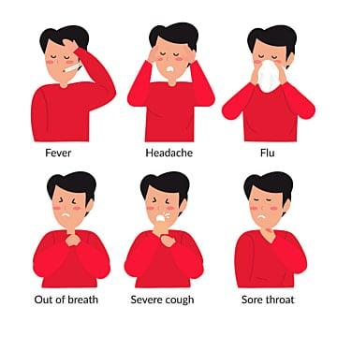
If students are very unwell, they should make a doctor’s appointment, retrieve a doctor’s note excusing them from school and give it to the Front Office when they are better. If a student tests positive to COVID, they should stay at home until they feel better or wear a mask to school. It is important not to spread germs and keep our community safe.

Getting in touch

Newsletter
The school’s newsletter is available in paper copy from the front office and can be downloaded from the school website once a term. It provides up to date information regarding all aspects of school life. A calendar is provided showing upcoming school events. http://www.evans-i.schools.nsw.edu.au/

Website
Evans IEC has a separate website to the high school. Please see the URL below. The website is edited weekly and communicates events and programs that are running in the IEC.

Staff
If you would like to get in touch with staff, you can email mary.kavanagh4@det.nsw.edu.au who will pass your details onto your child’s teachers.

Facebook and Instagram
Evans IEC recognises the importance of communication to build a strong and supportive school community. We promote upcoming events, share successes, and showcase photos and videos from the many exciting things that happen here at Evans. We welcome all students and parents to connect with us through our social media sites, but encourage you to participate appropriately, and to protect yourself online. This is especially important on Facebook and students should set their privacy levels to the highest level so that they protect themselves and the other people in our school.

@evans_iec
evansiec
https://evans-i.schools.nsw.gov.au/

Curriculum

Parent Teacher Evening
Students will receive a letter informing them of Parent Teacher Evening. Parents are encouraged to make an appointment to come to the school on that day and speak with all the teachers (interpreters will be arranged if necessary).

Reports
Students, guardians, and parents are issued with a full written report. The report outlines student achievements and progress.
- If the child is not leaving – they will receive reports in Terms 2 and 4
- All IEC students receive a Leavers Reports at the completion of their IEP course
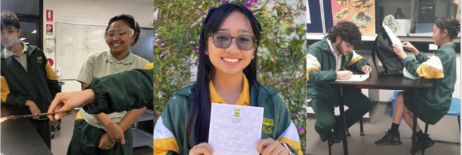
Students who have been at the IEC for five weeks or less will not receive a written report, but parents/guardians are still welcome to discuss the student’s progress at Parent Teacher Evening.

Homework
Each student should have a homework diary. Homework is given regularly and is an important part of school. It should be done by the student so that we can see what he/she understands. Teachers are happy to help if a student is having problems.
Year | Time per Night | Time per Week
7 | 30 minutes | 2.5 hours
8 | 1 hour | 5 hours
9 | 1.5 hours | 7.5 hours
10 | 2 hours | 10 hours

Sport
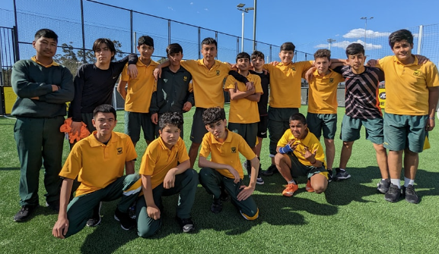
Sport is a valued and accepted part of a school’s curriculum because it contributes to the development of the whole student. It also provides opportunities for students to gain confidence and to develop a variety of skills for participation in lifelong recreation. Sport is compulsory for students. Students wear sport uniform to school on sport days. All students should wear black sport shoes. If this is not possible, then students can wear other sport shoes for sport and then change back into their black shoes when sport is finished.

Special Religious Education (Scripture)
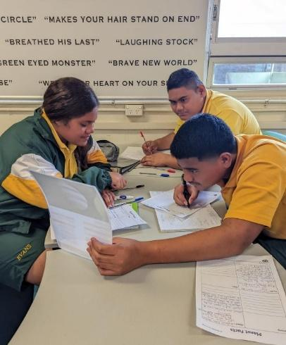
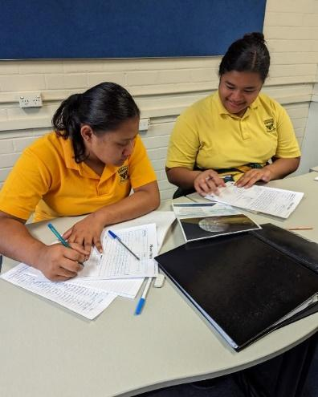
Special Religious Education involves authorised representatives of various religions providing instruction to students within school time. Parents can nominate their child's religious persuasion at enrolment and may withdraw from or change SRE classes by notifying the Front Office.

Extracurriculars
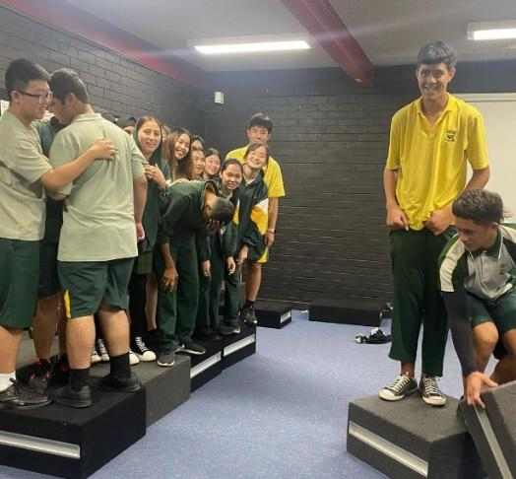
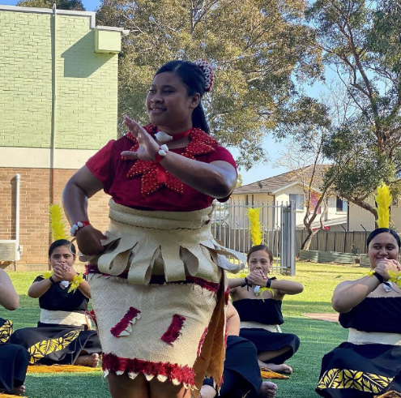
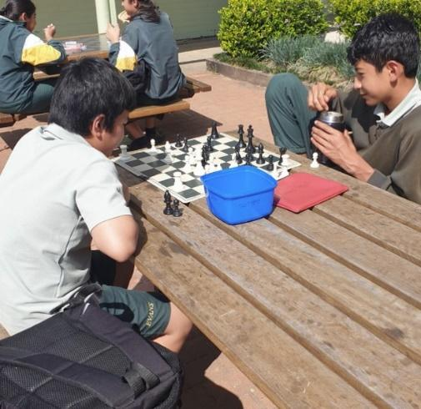

Mobile Devices
At Evans IEC, we use YONDR pouches. Students are expected to be trustworthy and follow teachers’ instructions regarding the use of mobile devices.
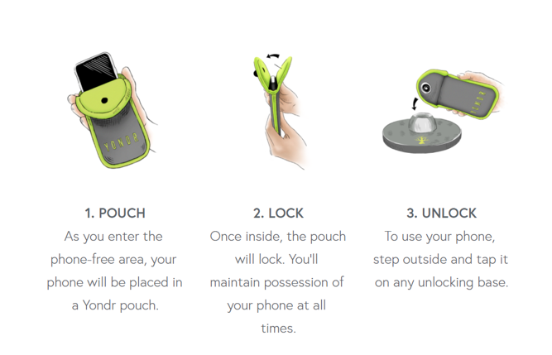

When you arrive at school | Unlock your pouch at one of the stations at the front or back of school. Turn your phone off or on silent before placing it in the pouch. Lock your pouch.

During Roll Call | Place your pouch on your desk to show your Roll Call teacher that your phone is safely locked away. Make sure your name is displayed. Even if your mobile phone is at home, you must display your pouch.

When you leave school | Unlock your pouch at one of the stations at the front or back of school. Move quickly from the area to ensure a smooth exit.

If you forget to unlock your phone | If you have forgotten to unlock your phone and you need access to it before the morning, you can unlock it at the front gate.

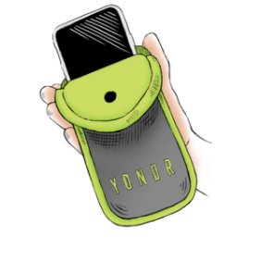

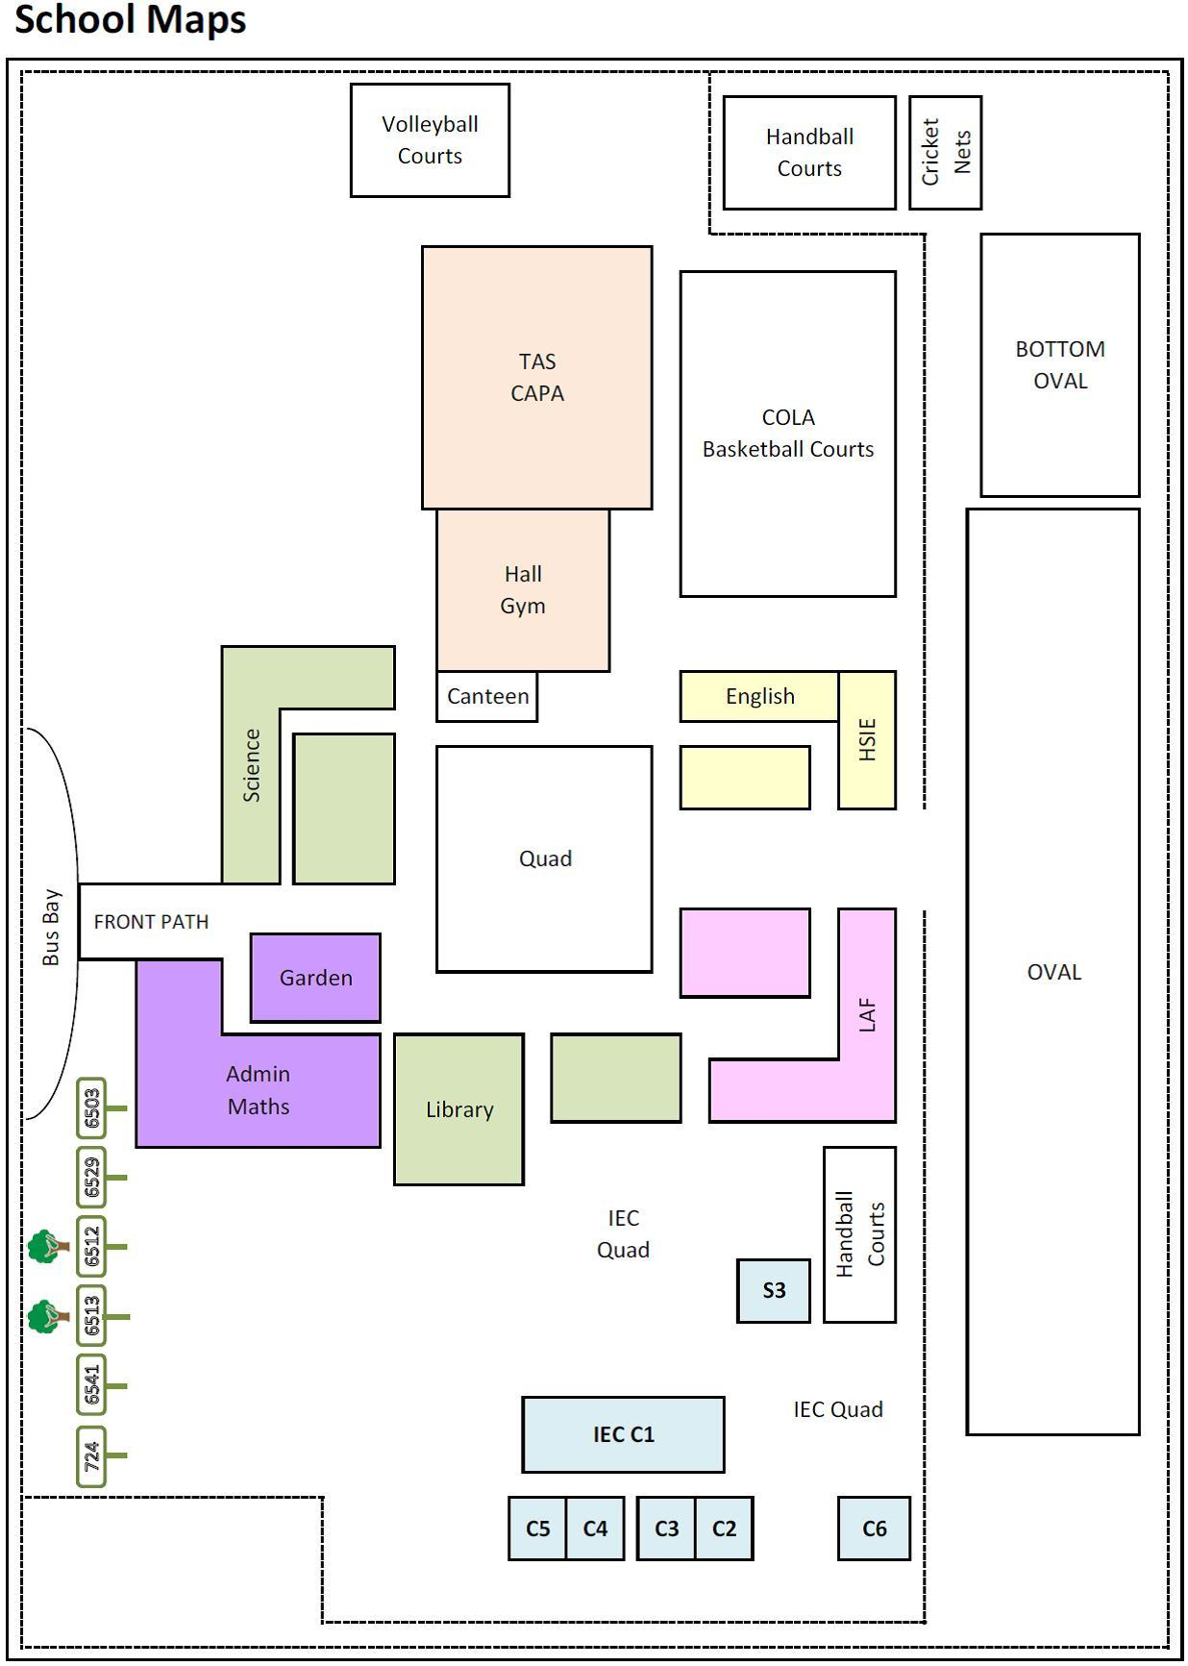
Maps

C7
C9
C10
C8
C11
C12
C13
C14
C15
C16
C17
C18
E1
E2

Playground
Area | Passive or Active | Equipment
Quad | Passive | No equipment to be used in this area
Oval | Active – Field | Students can play soccer and touch football. Under no circumstances are students to tackle one another
 | Passive – Silver Seats | No equipment to be used in this area
HSIE Quad and Toilets | Passive | No equipment to be used in this area
IEC Quad | Active – Table Tennis | Students can play Table Tennis in this area
 | Passive – Grass and Eating Area | No equipment to be used in this area
Canteen & Science Toilets | Passive | No equipment to be used in this area
COLA | Active - Basketball | Students can only play Basketball in this are
Courts | Active – Basketball and Handball | Students can play Basketball and Handball in this are
Walkways | Keep Clear – Out of Bounds
First floor and Stairs | Keep Clear – Out of Bounds

Wet Weather
Area | Passive or Active | Equipment
Quad | Passive | No equipment to be used in this area
Oval | Out of Bounds in Wet Weather | No equipment to be used in this area
HSIE Quad and Toilets | Passive | No equipment to be used in this area
IEC Quad | Passive | No equipment to be used in this area
Canteen & Science Toilets | Passive | No equipment to be used in this area
COLA | Active - Basketball | Students to play Basketball cautiously
Courts | Out of Bounds in Wet Weather | No equipment to be used in this area
Walkways | Keep Clear – Out of Bounds
First floor and Stairs | Keep Clear – Out of Bounds

Prohibited Items
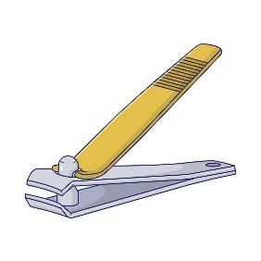
All members of the school community need a safe and supportive environment. Students must not bring prohibited items to school. These items include drugs, weapons or any item that can be used as a weapon. There will be severe consequences for students who do not follow this rule. Alcohol and cigarettes are also not allowed on school grounds.

Students that bring any of these items to school will immediately be referred to the Deputy Principal. Students may be formally cautioned and in some cases suspended. If you know that another student has any of these items on school grounds, it is important that you communicate this to a teacher.

Uniform
Wearing the correct uniform is very important. Students must wear the correct uniform every day. Your roll call teacher will check your uniform every morning.

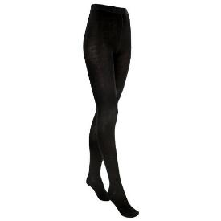

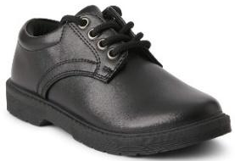

Uniform
Any of the following combinations are correct. Students are permitted to wear sport bottoms throughout the week. However, for hygiene purposes, sport shirts may only be worn on sport days.
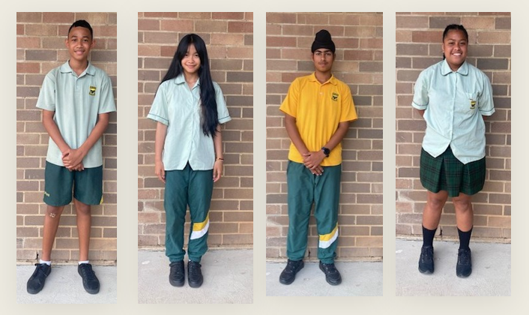
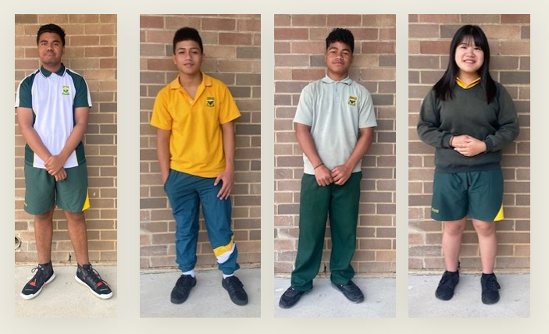
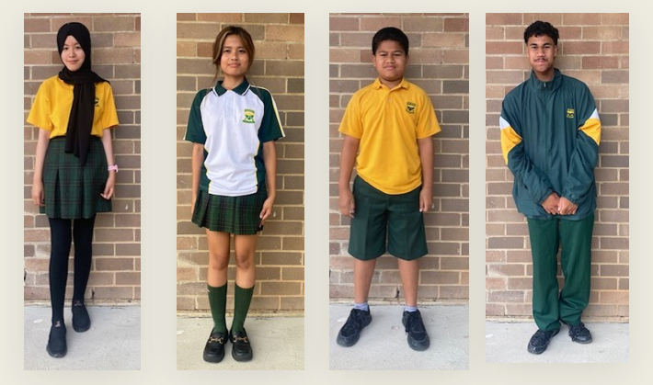

Uniform Shop
The Uniform Shop in C1 is open each school day before school and at recess.
Shirts, blouses and polos
Shirts | $15.00 | ‘Honeydew’ shirt, blouse or polo with school crest for Junior.  White shirt, white blouse or Evans Senior polo with school crest.  Long sleeves polos are available in some sizes or can be ordered.
Blouses | $15.00
Polos | $15.00
Senior Polos | $25.00
Trousers, shorts and skirts
Trousers | $30.00 | Bottle green: tailored shorts; tailored slacks; microfibre track –pants, stretch pants or Evans-design Tartan Skirt.  Black tailored trousers for seniors.  NOTE: plain green skirts or shorts or netball skirts are not uniform.
Boy’s School Shorts | $25.00
Skirt | $35.00
MicroFibre T.Pants | $25.00
Girls stretch pants/shorts | $25.00/  $20.00
Warm clothing
Jumpers | $20.00 | Bottle Green V-Neck Jumper (’Sloppy-Joe’); Bottle Green Polar Fleece; Evans Microfibre Jacket or Evans Blazer. [Microfibre Jacket and Microfibre Pants = Tracksuit.]  Seniors may wear white jumpers. Hooded Jumpers are not allowed.  [Any item of clothing such as scarves, a t-shirt or skivvy worn beneath the uniform must be plain white if visible at all.]
Polar Fleece | $20.00
Microfibre Jacket | $40.00
Whole Tracksuit | $60.00
Blazer | $65.00
White T Shirt | $ 5.00 | Undershirt –may be worn beneath the uniform
Sports uniform
On Sport day students wear sport uniform to school.
For PE lessons students carry sport uniform to school
Polos | $15.00 | ‘Yellow’ Polo with school crest
Shorts | $20.00 | Green Unisex sports short
Taslon Track Pants | $30.00 | School Taslon Track pants with Yellow flash  (NOTE: These may only be worn for sport or P.E.)
Optional
School Tie | $15.00 | Any students may purchase and wear the school tie.
School Caps | $ 5.00 | If a hat is worn it must be bottle green or black without decoration/logo.
School Beanie | $ 5.00 | Plain bottle green/black without decoration
Other
Footwear |  | All-black shoes or trainer style shoes. These must completely cover the foot and be leather or suede.
Socks |  | Socks/stockings must be worn. Socks: all-white or all-black (i.e. no stripes/patterns) Stockings: plain & black or skin-toned. No Leggings.
Jewellery, Makeup |  | Simple jewellery: watch, plain ring, sleeper earnings or plain studs, fine neck chain, single bracelet or bangle.
Headwear, hijabs, scarves |  | All headwear should be black, white or bottle green.

Canteen (food)
Students can bring their food from home or buy it from the canteen. Students are not allowed to leave the school grounds to buy food. The school canteen operates every school day. As students’ mobile phones are kept in YONDR pouches, student must purchase their food with cash or a bank card that is kept in their wallet.
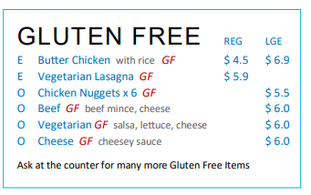
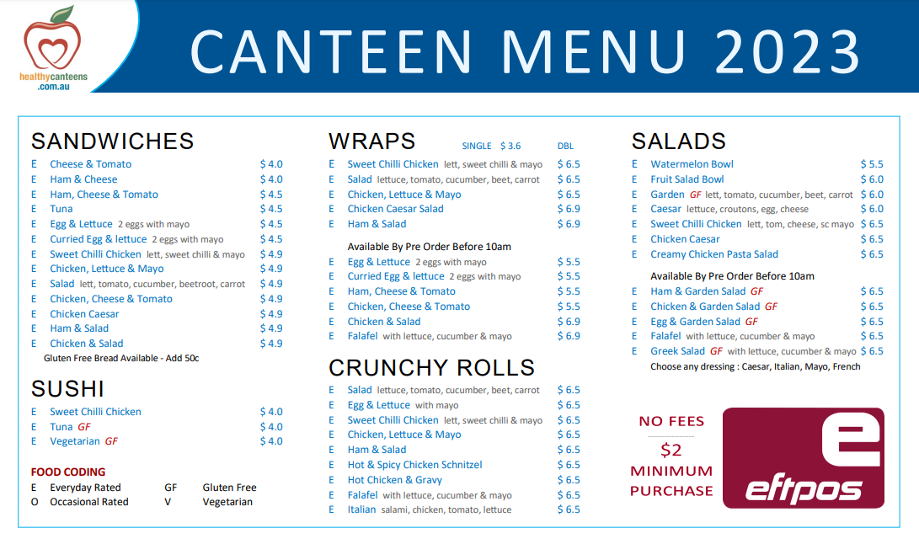
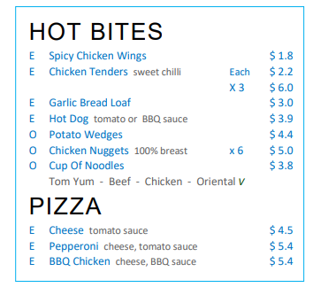
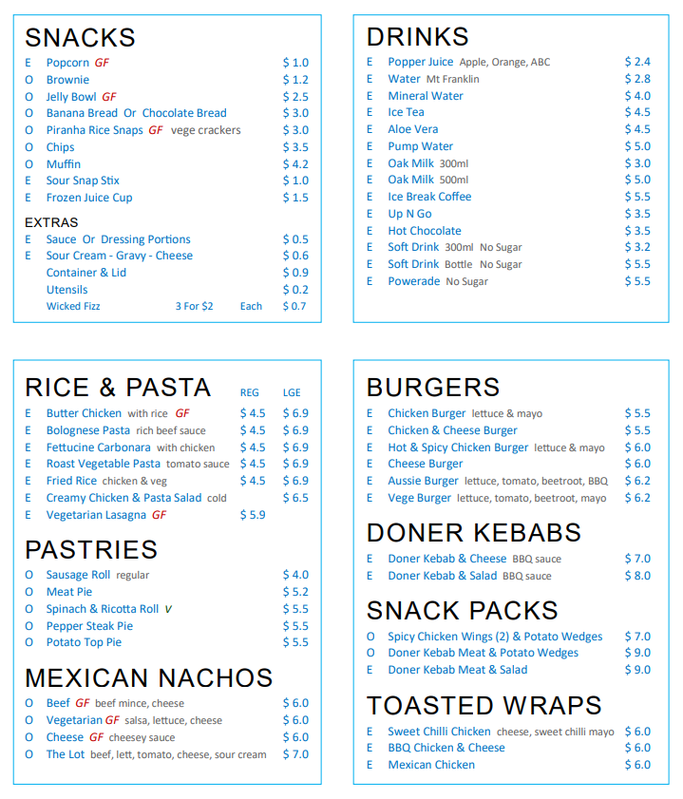

Travel

Opal Cards
Free Opal Cards are given to students (except for international students and some fee-payable VISAs) who live more than 2.9 km from Evans IEC by the most direct walking route to the school. There is usually a delay of approximately two weeks before the Opal Card is issued by Transport NSW. If an Opal Card is lost, the student must tell the office staff who will order a replacement Opal Card, with a cost of $10.

School bus from blacktown station

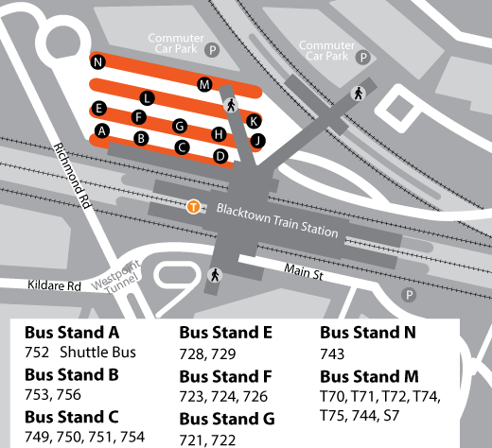

School Bus timetable
Evans High School and Intensive English Centre

Morning

Bus | Route | Time | Location | Route
- | 724 | 7:42am | Blacktown | Departs Blacktown Station via Patrick St to Westpoint Interchange (Rank 10), continues Patrick St (R)Newton Rd (L)Balmoral St (R)Bungarribee Rd (L)Walters Rd to School.
6064 | - | 7:50am | Blacktown | Departs Blacktown Station (Rank M) via (L)Balmoral St (R)Kildare Rd (L)Walters Rd to School.
6034 | - | 7:51am | Doonside South | Departs Kildare Rd & Balmoral St via Kildare Rd (L)Rosenthal St (L)Bungarribee Rd (R)Walters Rd (R)into School bus bay.
6040 | - | 7:53am | Blacktown | Departs Blacktown Station (Rank N) via Patrick St to Westpoint Interchange (Rank 9) continues Patrick St (R)Newton Rd (L)Walters Rd to School.
- | 724 | 8:02am | Blacktown | Departs Blacktown Station via Patrick St to Westpoint Interchange (Rank 10), continues Patrick St (R)Newton Rd (L)Balmoral St (R)Bungarribee Rd (L)Walters Rd to School.
6005 | - | 8:09am | Blacktown | Departs Blacktown Station (Rank M) via (L)Balmoral St (R)Kildare Rd (L)Walters Rd to School.

Afternoon

Bus | Route | Time | Location | Route
- | 724 | 1:11pm | Blacktown | OPERATES ON WEDNESDAYS ONLY  Departs School via (L)Walters Rd (R)Bugarribee Rd (L)Bamoral St (R)Newton Rd (L)Patrick St to Blacktown Station (1:25pm).
6503 | - | 1:15pm | Blacktown | OPERATES ON WEDNESDAYS ONLY  Departs School via (L)Walters Rd(R)Newton Rd (L)Patrick St to Blacktown Station (1:25pm).
6512 | - | 1:15pm | Doonside South | OPERATES ON WEDNESDAYS ONLY  Departs School via (L)Walters Rd (L)Bungarribee Rd (R)Lancaster St (R)Kildare Rd to Balmoral St (1:28pm).
6541 | - | 1:16pm | Doonside | OPERATES ON WEDNESDAYS ONLY  Departs School via (L)Walters Rd (L)Bungarribee Rd (R)Rosenthal St (R)Kildare Rd to Ash St (1:31pm).
6513 | - | 1:18pm | Blacktown | OPERATES ON WEDNESDAYS ONLY  Departs School via (L)Walters Rd (R)Newton Rd (L)Balmoral St (R)Kildare Rd (L) Overbridge to Blacktown Station (1:30pm).
6529 | - | 1:18pm | Blacktown | OPERATES ON WEDNESDAYS ONLY  Departs School via (L)Walters Rd (R)Newton Rd (L)Balmoral St (R)Kildare Rd (L) Overbridge to Blacktown Station (1:30pm).
6512 | - | 2:55pm | Doonside South | DOES NOT OPERATE ON WEDNESDAYS  Departs School via (L)Walters Rd (L)Bungarribee Rd (R)Lancaster St (R)Kildare Rd to Balmoral St (3:08pm).
6503 | - | 2:55pm | Blacktown | DOES NOT OPERATE ON WEDNESDAYS  Departs School via (L)Walters Rd (R)Newton Rd (L)Patrick St to Blacktown Station (3:05pm).
6529 | - | 2:55pm | Blacktown | DOES NOT OPERATE ON WEDNESDAYS  Departs School via (L)Walters Rd (R)Newton Rd (L)Balmoral St (R)Kildare Rd (L) Overbridge to Blacktown Station (3:07pm).
6541 | - | 2:56pm | Doonside | DOES NOT OPERATE ON WEDNESDAYS  Departs School via (L)Walters Rd (L)Bungarribee Rd (R)Rosenthal St (R)Kildare Rd to Ash St (3:11pm).
6513 | - | 2:58pm | Blacktown | DOES NOT OPERATE ON WEDNESDAYS  Departs School via (L)Walters Rd (R)Newton Rd (L)Balmoral St (R)Kildare Rd (L) Overbridge to Blacktown Station (3:10pm).
- | 724 | 3:01pm | Blacktown | DOES NOT OPERATE ON WEDNESDAYS  Departs School via (L)Walters Rd (R)Bungarribee Rd (L)Balmoral St (R)Newton Rd (L) Patrick St to Blacktown Station (3:15pm).

Speak to Miss Kavanagh if you would like a bus buddy 😊

Welcome to Evans Intensive English Centre

